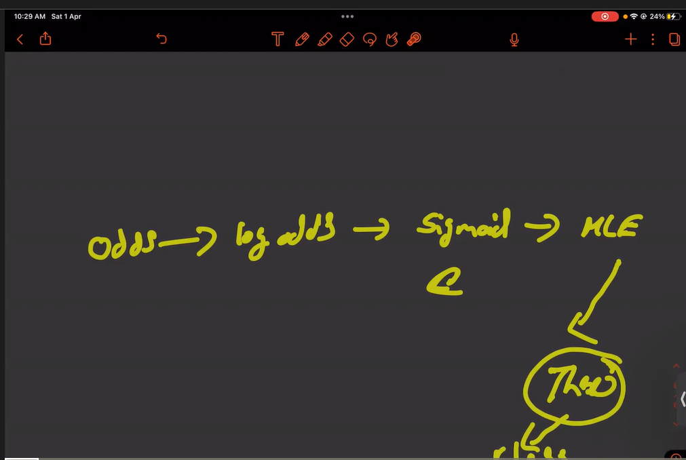

In Logistic we evalute the performance using metrices like confusion metrices

Accuracy, Precision, Recall, F1 score matrices

Classification metrices

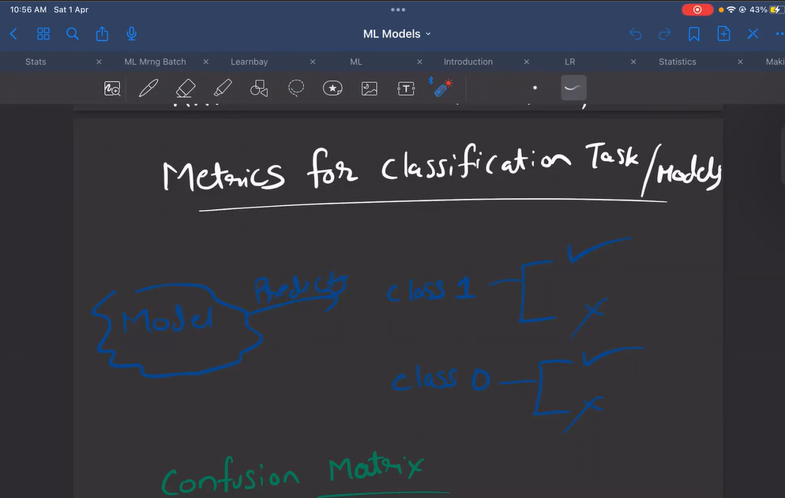

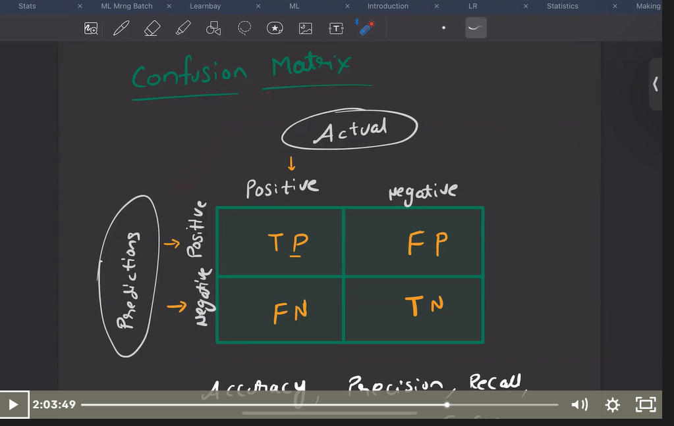

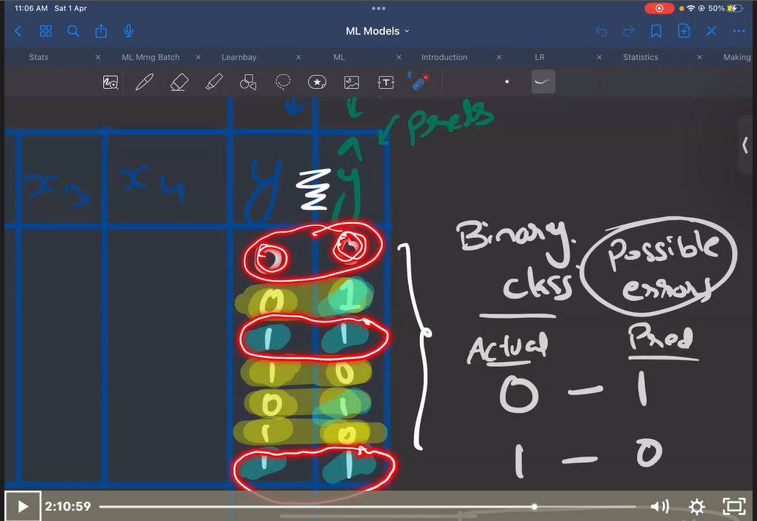

When we get multiple classification output / c1/c2/c3/c4 instead of binary output (0/1).In this 0.7 is high which is class 1 and it will internally convert into many split and compare the best accuracy.

